NEPAL ENGINEERING COLLEGE
(Affiliated to Pokhara University)

Changunarayan, Bhaktapur



Report on

FAMILIARIZATION WITH DISCRETE-TIME LTI SYSTEM

Submitted by: Submitted To:

Aruna Thapa

Roll no: 021 – 311 Electrical engineering
Date :14/06/2024

FAMILIARIZATION WITH DISCRETE-TIME LTI SYSTEM

Objective
In this lab session, we will study discrete-time Linear Time-Invariant (LTI) systems and their responses using MATLAB. We will analyze system responses using convolution and LCCD (Linear Constant Coefficient Difference) equations, evaluate impulse and step responses, and assess system stability. This lab enhances understanding of fundamental concepts of LTI system behavior through MATLAB simulations.

Theory
A discrete-time LTI system can be characterized either by its impulse response h[n] or by a difference equation. MATLAB provides functions like conv and filter to compute these responses. Understanding these systems is critical in signal processing applications such as filtering, prediction, and system identification.
The convolution sum gives the output of an LTI system for an arbitrary input if the impulse response is known. The LCCD equation models the system based on current and past inputs and outputs. MATLAB's filter function simplifies solving such equations. Additionally, impulse and step responses reveal a system's inherent characteristics, while the system's stability is determined by the behavior of these responses over time.

Convolution Sum
The convolution of two discrete-time signals can be found using the MATLAB command conv.
This
command helps to find the convolution of two causal signals.

Question #1:
  - Find the convolution of the two signals x1(n)= {1,2,3,4} and x2(n)= {2,3,4,5} and plot the result of the convolution.
% CRN: 021-311 - Convolution of Causal Signals x = [1 2 3 4];
h = [2 3 4 5];
y = conv(x, h);
stem(y);
title('CRN: 021-311 - Convolution Result'); xlabel('n'); ylabel('y[n]'); grid on;

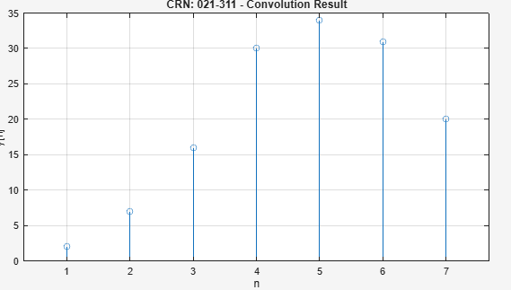

This figure shows the result of convolving two causal discrete-time signals x[n]={1,2,3,4} and h[n]={2,3,4,5}. The output y[n] represents the system response due to the input signal, computed using MATLAB’s conv() function.

  - Write a user defined function to calculate convolution of two non-causal discrete-time signals.

function [y, ny] = noncausal_conv(x, nx, h, nh)  % Convolution of two non-causal discrete-time signals  y = conv(x, h);  ny_start = nx(1) + nh(1); ny_end = nx(end) + nh(end);  ny = ny_start : ny_end;  end clear; clc;  % Define signal x[n] x = [1 2 1];  nx = -1:1;  % Define signal h[n] h = [1 -1];  nh = 0:1;  % Call the function  [y, ny] = noncausal_conv(x, nx, h, nh);  % Display results disp('y = '); disp(y);  disp('ny = ');  disp(ny); | Output  y =  1 1 -1 -1  ny =  -1 0 1 2

LCCD Equation:
A general linear constant coefficient difference (LCCD) equation is given by
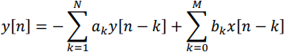
Where {ak} and {bk} are constant coefficients. To implement DT LTI system described by LCCD equation in MATLAB, filter() command is used.

Question 2#:
  - Use MATLAB to implement following special system described by LCCD equation
- A three-point smoothing filter: y[n] = 1/3(x[n] + x [n-1 + x[n-2]])
- The differentiator: y[n] = x[n]− x[n −1]
- The Accumulator: y[n] = x[n]+ y[n -1]

clear; clc; close all;
%
% Input Signal (You can change)
%
x = [1 2 3 4 5 4 3 2 1];
%
% 1. THREE-POINT SMOOTHING FILTER
% y[n] = (x[n] + x[n-1] + x[n-2]) / 3
%
b1 = [1/3 1/3 1/3]; % numerator coefficients a1 = [1]; % denominator coefficients
y_smooth = filter(b1, a1, x);
% Plot figure;
subplot(2,1,1); stem(x); title('021-311 Input Signal x[n]');
subplot(2,1,2); stem(y_smooth); title('021-311 Three-Point Smoothing Filter Output');

%
% 2. DIFFERENTIATOR
% y[n] = x[n] - x[n-1]
%
b2 = [1 -1];
a2 = [1];
y_diff = filter(b2, a2, x); figure;
subplot(2,1,1); stem(x); title('021-311 Input Signal x[n]'); subplot(2,1,2); stem(y_diff); title('021-311 Differentiator Output');

%
% 3. ACCUMULATOR
% y[n] = x[n] + y[n-1]
%
% LCCD → y[n] - y[n-1] = x[n]
%
b3 = [1];
a3 = [1 -1];
y_acc = filter(b3, a3, x); figure;subplot(2,1,1); stem(x); title('021-311 Input Signal x[n]'); subplot(2,1,2); stem(y_acc); title('021-311 Accumulator Output');

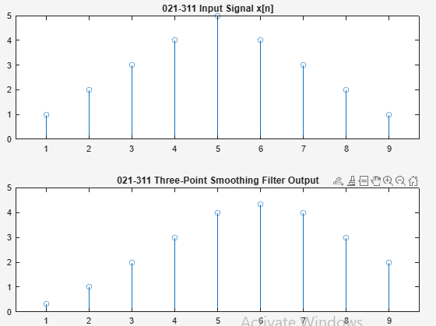
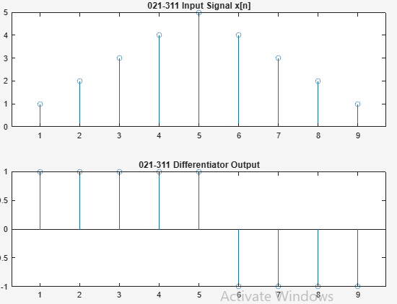
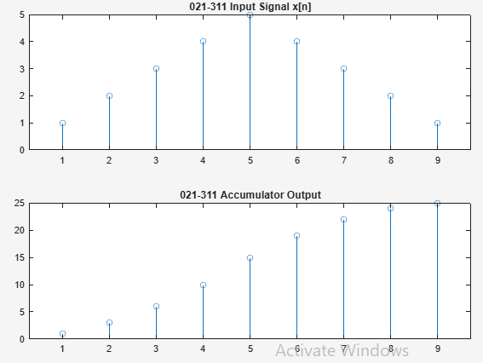

  - Write a MATLAB program that generates two sinusoidal signals x1 and x2 with relative frequencies f1 = 0.05 and f2 = 0.47. The two signals should be added, and the resultant signal x is applied to the three-point smoothing digital filter. Plot the signals x1, x2, x and y in single figure using subplot.
% CRN: 021-311 - Three-point Smoothing Filter f1 = 0.05; f2 = 0.47; n = 0:100; x1 = sin(2pif1n);
x2 = sin(2pif2n); x = x1 + x2;
B = [1 1 1]/3;
A = 1;
y = filter(B, A, x);
subplot(4,1,1); plot(x1);
title('CRN: 020-311 - x1[n]');
subplot(4,1,2); plot(x2);
title('CRN: 021-311 - x2[n]');
subplot(4,1,3); plot(x);
title('CRN: 021-311 - x[n]');
subplot(4,1,4); plot(y);
title('CRN: 021-311 - y[n]');

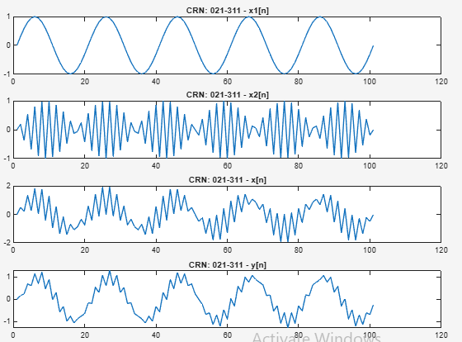

This four-panel figure illustrates the process of generating two sine signals x1[n] and x2[n] adding them to form

x[n]x[n]x[n], and passing the sum through a three-point smoothing filter to obtain y[n]. It demonstrates how a smoothing filter reduces high-frequency components.

Impulse Response
Question 3#:
  - Generate a unit impulse sequence and pass it through the three-point smoothing filter, the differentiator, and the accumulator. Plot the impulse responses of the systems.

% CRN: 021-311 - Impulse Responses n = 0:20;  d = [1, zeros(1,20)];  h1 = filter([1 1 1]/3, 1, d);  h2 = filter([1 -1], 1, d);  h3 = filter(1, [1 -1], d);  subplot(3,1,1); stem(n, h1); title('CRN: 021-311 - Smoothing Filter');  subplot(3,1,2); stem(n, h2); title('CRN: 021-311 -  Differentiator'); subplot(3,1,3); stem(n, h3);  title('CRN: 021-311 - Accumulator'); | 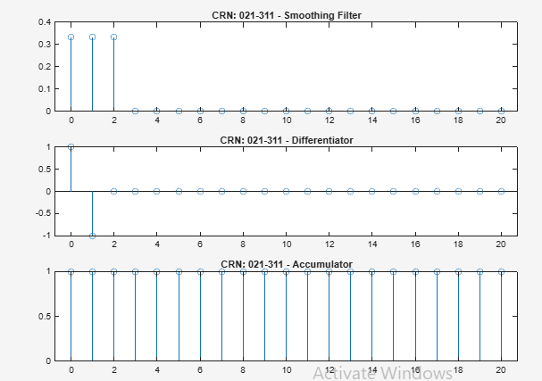
This figure shows the impulse responses of the three systems: smoothing filter, differentiator, and accumulator. Each subplot depicts how the system reacts to a unit impulse, illustrating fundamental system behavior.

  - A built-in MATLAB function impz helps to find and plot impulse response of LTI system. Plot impulse response of the systems and compare the results obtained in part i.
% CRN: 021-311 Using impz()
subplot(3,1,1); impz([1 1 1]/3, 1); title('CRN: 021-311 - Smoothing Filter - impz');
subplot(3,1,2); impz([1 -1], 1);
impz');
subplot(3,1,3); impz(1, [1 -1]);
title('CRN: 021-311 - Differentiator -
title('CRN: 021-311 - Accumulator -impz');

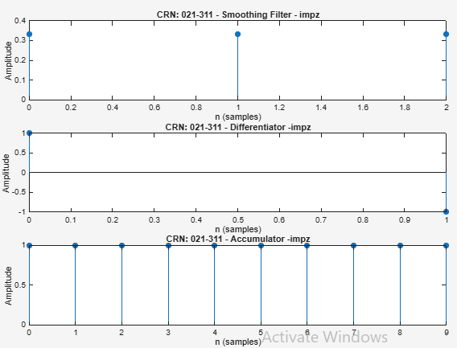

Stability
Question 4#:
Check the stability test for the Accumulator, the Differentiator and Three-point smoothing filter. Also write a user defined MATLAB function to check whether the given LTI system is stable or not.
function isStable = check_stability(b, a)
% CHECK_STABILITY Checks stability of an LTI system defined by (b,a)
%
% Usage:
% isStable = check_stability(b, a)
%
% Output:
% isStable = 1 (stable) or 0 (unstable)
% Calculate poles of the system poles = roots(a);
% Display poles
disp('Poles of the system:'); disp(poles);
% Check if all poles lie inside the unit circle if all(abs(poles) < 1)
disp('The system is STABLE.'); isStable = 1;
else
disp('The system is UNSTABLE.'); isStable = 0;
end
end
disp('---- Three-Point Smoothing Filter ');
check_stability([1/3 1/3 1/3], [1]); disp('---- Differentiator ');
check_stability([1 -1], [1]);
disp('---- Accumulator ');
check_stability([1], [1 -1]);

Output:

---- Three-Point Smoothing Filter ----
The system is stable.

---- Differentiator ----
The system is stable.

---- Accumulator ----
Pole of the system: 1

